**№13**

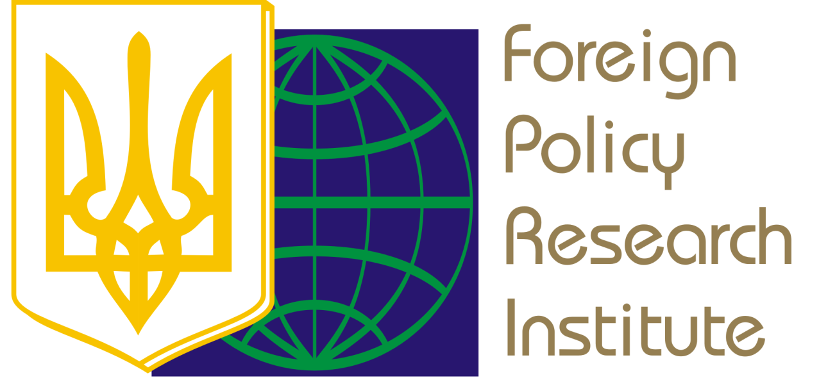

# UKRAINE – THE EUROPEAN UNION

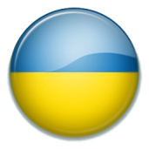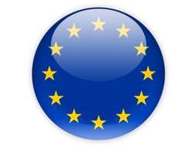

***KEY THEME ANALYSIS***

***THE EU AND UKRAINE DECIDED TO STRENGTHEN SANCTIONS AGAINST RUSSIA. NOW THEY SHOULD IMPLEMENT THEM ESSENTIALLY***

**The decision to impose the third level sanctions** on the Russian Federation was agreed by the ambassadors of the EU member states on July 29, 2014 – after the months of almost undisguised aggression, thousands murdered Ukrainians and almost 300 dead EU citizens – passengers of ‘Boeing’, which was shot down by Russian militants in Donbas. Six weeks later **the Ukrainian Parliament adopted the law on sanctions against Russian aggressors**.

***The new EU sanctions against Russia are usually called ‘sectoral’, while in fact they do not relate to the whole sectors of economy***, but only to the banks and companies, controlled by the Russian state or by the oligarchs, who are directly involved in aggression to Ukraine. Russian state banks were restricted from the long-term loans, and state oil companies – from the new high-tech equipment (including those for the deepwater drilling). Sale of weapons and dual-use goods to Russia was also banned.

However, ***the restrictions apply only to the new contracts, so all the existing agreements with oil companies as well as deals on the weapons supply, including the French ‘Mistrals’, will continue operating***. Besides, nothing may prevent Russians from circumventing sanctions by the involving loans through the private banks, which are indirectly controlled by the Kremlin, as well as by the business contracts through the third countries. For example, in August 2014, when the EU sanctions were already formally in force, Russian state company ‘Rosneft’ has bought a stake in one of the world's largest oilfield service companies – Swiss ‘Weatherford’, and signed an agreement on marine drilling wells with the Norwegian ‘North Atlantic Drilling Ltd.’[1] It should also be recalled that the management of such business giants as OMV, BASF, Siemens, ExxonMobil have repeatedly announced their intention to continue doing business with Russia.

It is also clear that **the EU decision was too late, because such limited sanctions could stop the Kremlin in March**, when it had already annexed the Crimea, but has not yet managed to convince own population of the inevitability of Donbas separation from Ukraine. At that time Putin's rating rose to an unprecedented 80%, and the majority of the Russia’s population was in euphoria of ‘Crimea is our!’ However, just a few weeks later the Russian media began to zombify people with the ideas of Russia's annexation of the entire Central and Eastern Ukraine (the so-called ‘New Russia’). Russians have been living with these aspirations for the last months. Therefore **the refusal to support the separatism in Donbas just now may be more expensive for Putin (in terms of public support), than the current limited EU sanctions**, moreover the Kremlin reasonably expects to circumvent the sanctions due to the sabotage by the number of large European companies and by some EU member states.

**The EU should act proactively to stop Putin – the losses from the sanctions must be more painful than potential electoral losses of the Kremlin Boss**, who does not want to disappoint the Russia’s population, infected with the imperial ambitions. The EU should remember that after the ‘Donbas is our!’ and ‘Ukraine is our!’ Russian voters will demand from Putin more ‘victories’, and he will be ready to do anything to keep his 80% popularity. ***No rational argument will work in Russia, until those 80% of the population, who support Putin's aggression, feel on their own wallets the expensiveness of it***.

To be fair, it should be noted that **even the current ‘half-sanctions’ already give a certain result**. Recently, the president of ‘Rosneft’ Igor Sechin has asked the Russian government to support the company at $42 billion.[2] And the profit of ‘Gazprom’ in the first half of 2014 decreased by 36% compared to the previous year.[3]

**On August 14 the Ukrainian Parliament finally adopted the law to impose sanctions against the Russian aggressors.** Significantly, the Ukraine adopted the law on sanctions six weeks (!) after the introduction of the third stage sanctions by the European Union. It is indicative also that the law was supported by only 244 MPs (and respectively nearly 200 MPs did not support it) – this fact confirms the need to dissolve the present Parliament. **The good news is that the wide range of areas of possible sanctions should make them really effective**. They include: blocking and freezing of the assets, restrictions on trading activities, prohibition to participate in the privatization, license revocation, suspension of transit through the territory of Ukraine, prohibition to export the capital, technology transfer ban and etc.

Sanctions may be imposed in the case of the actions of a foreign state, a foreign natural or legal person or other subjects, which create threats to the national interests and security, sovereignty and territorial integrity of Ukraine. If the sanctions are imposed on the specific individual or legal entity, then a decision must be taken by the National Security and Defense Council of Ukraine, followed by the signature of the President. If the sanctions are imposed on the entire country or a range of subjects, then the Presidential decree must be approved by the Parliament. Currently, the government has prepared a package of sanctions against 172 individuals and 65 entities, mostly Russian, involved in the aggression against Ukraine.

It should be noted that, ***due to the OSCE position, the Ukrainian Parliament withdrew from the law the points relating to the restrictions on postal service, the termination of TV coverage and media outlets***. This would limit the ability of Ukrainian authorities to respond quickly to the spread of Russian propaganda through the Kremlin-controlled media, operating in Ukraine.

***European officials also expressed reservations about the possible termination of Russian oil and gas transit through the Ukrainian territory***. Relevant statements have been already made by the energy commissioner Günther Oettinger[4] and by the Germany government spokesman Steffen Seibert.[5] However, none of them offered more effective mechanism to encourage Russia to cease its gas pressure on Ukraine (the latter don’t receive gas for two months). We can assume that the Ukrainian government is planning to use the threat of energy transit termination as a leverage in the gas dispute with Russia, as well as a leverage to deterrence Russia’s direct military aggression.

Both the EU and Ukraine have the legal mechanisms to impose the sanctions, which may make the continuation of Russian aggression enormously expensive for Putin. Will it be enough expensive to force him at least temporarily postpone the intention to revive the Russian Empire in the borders of 1914? This will depend on how faithfully the EU’s and Ukrainian governments and businesses execute the sanctions. **It is also important to prevent Russia’s circumventing sanctions through the deals with the third countries**. It should be clear for Switzerland, China and Latin America countries that the attempts of their companies to make money on the confrontation would lead to the proportional losses in the Ukrainian and European markets.

# UKRAINE – NATO

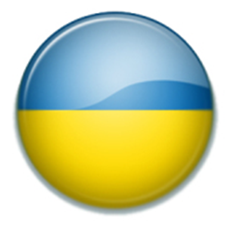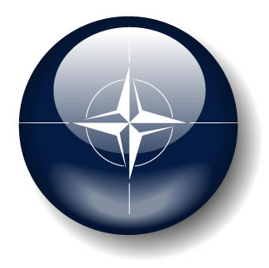

***KEY THEME ANALYSIS***

***RASMUSSEN'S VISIT TO KYIV AND***

***THE EXPECTATIONS FROM THE NATO SEPTEMBER SUMMIT***

**On August 7, 2014 NATO Secretary General Anders Fogh Rasmussen visited Kyiv**. The very fact of the Alliance Secretary General visit has become an important support, especially on the eve of the planned invasion of the Russia’s so-called ‘humanitarian convoy’ – about 300 KAMAZ trucks with the unknown load, accompanied by the Russian soldiers. Mr. Rasmussen met with the senior Ukraine’s officials – President Petro Poroshenko, Prime Minister Arseniy Yatsenyuk, Speaker Oleksandr Turchynov, and discussed with them the prospects of NATO-Ukraine cooperation, including the Annual National Programme and four ***NATO Trust Funds to support the Ukraine's defensive capacities***, including logistics, command and communications, cyber security, and social adaptation of the retired servicemen.

Three principal emphases of the visit should be noted:

**1. NATO Secretary General and the President of Ukraine spoke about the prospects of Ukraine's membership in NATO**. Mr. Rasmussen noted that according to the decision of the Bucharest Summit in 2008, NATO’s door remains open to Ukraine. He also said: *"Today Ukraine has a law that defines its neutral status. We respect it.* ***If Ukraine decides to change this law, we will also respect it****".* In response Mr. Poroshenko said that due to recent developments a significant growth is noticed among the Ukrainians in the number of supporters of the Euro-Atlantic course of Ukraine, and it cannot be ignored in the perspective.[6]

**2. Anders Fogh Rasmussen has officially invited Petro Poroshenko to participate in NATO summit to be held in Wales on September 4-5, 2014**. Key issues of the European Allies security enhancements and the format of the assistance to Ukraine will be discussed at the summit. In particular, NATO intends to adopt a new exercise schedule and to approve the decision to strengthen the NATO Response Force. Poland and the Baltic states insist on the decision to establish the NATO military bases on their territory. Supreme Allied Commander Europe Gen. Philip Breedlove supports the idea to create the NATO military base in the Polish city of Szczecin on the Baltic Sea. However, it may happen that NATO will adopt the ‘compromise’ solution, formally not contrary to the NATO-Russia Founding Act, namely – to establishing in the Eastern Europe the stockpiles of weapons and food and the military infrastructure, which may allow to quickly increase the number of NATO troops.

**A joint NATO-Ukraine declaration should be adopted, which will determine the development of relations in the coming years**. On August 4 British Prime Minister ***David Cameron said that Russian aggression in Ukraine will be the main item on the agenda of the summit***: "First of all is NATO's response to the Russian-Ukrainian crisis. Since Russia destabilised Ukraine and illegally annexed Crimea, NATO's response has focused on reassuring our eastern allies and deterring Russian aggression elsewhere... I support General Breedlove's plans to reinforce NATO's headquarters in Poland, to preposition equipment and supplies and to schedule a series of exercises that will make clear we will not be intimidated by Russia's aggressive behaviour".[7]

**3. NATO Secretary General said about the termination of cooperation with Russia and at the same time about the strengthening of cooperation with Ukraine**: "NATO stops cooperation with Russia, strengthens collective defense to protect all of its members, and decided to increase the level of support and cooperation with Ukraine."[8] Such a shift in priorities is important because for the previous years NATO de facto placed the priority on the relations with Russia before the cooperation with Ukraine. Brussels traditionally looked at Kyiv through the prism of relations with Moscow, and such a politics was one of the factors, which led to the current dangerous situation.

Against this background, **NATO and the U.S. unwillingness to provide military assistance to Ukraine continues to disappoint**. During his visit to Kyiv Mr. Rasmussen stated again that the supply of military equipment is not within the scope of NATO. A few days later, in the interview to ‘Reuters’ NATO Secretary General said about "high probability" of Russia’s militarily intervention to the Eastern Ukraine "under the guise of a humanitarian operation". But even in the case of direct Russian aggression, Ukraine couldn’t count on the Alliance’s military help: "However, we are not considering military operations. If the Russians were to intervene further in Ukraine, I have no doubt that the international community would respond determinedly, notably through broader, deeper, tougher economic sanctions that would isolate Russia further."[9]

**It is obviously that such NATO position is dictated by the Washington policy. At the press conference on August 7, Barack Obama rejected again the possibility of arms supplies to Kyiv**, alleging that "Russian army is a lot bigger than the Ukrainian army" and that Russia has not yet invaded to Ukraine openly.[10] Such arguments do not hold water, because even a smaller army can successfully deter the aggression of a more numerous one, if it has a good weapon. If Ukraine has a large number of the modern effective weapons – the likelihood of Russia’s full-scale invasion will reduce. In recent months Ukrainian army rapidly typed experience and demonstrated success in the fight against the Russian militants, including many Russian special forces soldiers. But the lack of modern weapons, including drones, prevents Ukraine from the quick completion of the anti-terrorist operation, as well as from the decreasing of the number of victims.

**Such a position of the United States and of their European allies looks even stranger, given that they are planning to provide the military assistance to the Iraqi Kurds – to fight against the ‘Islamic State’** **militants.** France and Italy initiated considering the question of military assistance to the Kurds at the next Council meeting. German Foreign Minister said also about the possibility of the military assistance to the Iraqi Kurds.[11] The question is – why NATO members can assist with weapons to the Iraqi Kurds, who fight against the terrorists, but they cannot do the same for the Ukrainians, who fight against the terrorists also?

Now it seems that in the Washington prevails the position of those, who believe that Ukraine is a great example, which should convince the European allies in the need to care more about the strengthening of NATO and of their own security. **The Ukrainian authorities need to convince the colleagues in Washington and Brussels that thousands of dead Ukrainians is too expensive price for the ‘sobering’ of the Europe and for the return of the American leadership in the world**, and that both tasks can be successfully realized without sacrificing our citizens and our territories.

**Urgent and radical strengthening of the Ukrainian armed forces is even better recipe to deter the Russian aggression** than the increasing of military spending of the NATO members. Because Putin will dare to the direct aggression only if he will be sure in the quick victory without the losses of many Russian soldiers (which is possible only against the weak Ukrainian army). The lack of confidence in the easy victory (if the Ukrainian army is strengthened) could protect from disaster not only Ukraine, but also Russia itself, as well as Europe and the U.S., since no one can predict the behavior of the megalomaniac dictator, if he do not have way back, but still control the powerful nuclear arsenal.

# FOREIGN POLICY OF UKRAINE

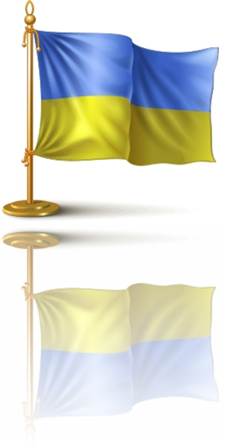

***KEY THEME ANALYSIS***

***THE ‘HUMANITARIAN CONVOY’ INDICATES RUSSIA'S DECISION TO LAUNCH A DIRECT INVASION UNDER ANY PRETEXT***

**The persistent attempts of Russia to force through the idea of its ‘humanitarian’ invasion to Donbas may indicate that the Kremlin has taken the ultimate decision on direct aggression and is just looking for the formal excuse**.

In early August Moscow failed to ‘legalize’ its invasion through the UN Security Council – its proposition on sending Russian ‘convoys with humanitarian aid’ to Donetsk and Luhansk was not supported. Then the Kremlin decided to act under the guise of the Red Cross. However, the head of this organization also refused to take responsibility for the three hundred Russian KAMAZ trucks with unknown load; at the same time, Moscow refused to hand over its ‘aid’ to the Red Cross on the Ukrainian border. After the unsuccessful attempts to bring the so-called ‘humanitarian convoy’ through the border in Kharkiv region, Moscow directed its trucks towards that part of the border in Luhansk region, which is controlled by the separatists, armed by Russia.

Kremlin attempts to fool the world leaders with the guise of ‘humanitarian aid’ did not entrap anyone – Barack Obama, Angela Merkel, José Manuel Barroso, Anders Fogh Rasmussen, Donald Tusk – all said that Russian invasion under the guise of a humanitarian mission was inadmissible. At the same time, European and American partners did not proposed Kyiv any effective way out of the difficult situation: **on the one hand, the rejection of the humanitarian aid could be used by Moscow as a pretext for the ‘humanitarian intervention’ (a military intervention in fact)**. Apparently the fear of such possibility forced Western leaders to put pressure on Kyiv with recommendations to accept the Russia’s ‘humanitarian aid’ in any possible format.

**On the other hand, the ‘humanitarian convoy’ in the format, in which Moscow demanded to accept it** (in the Russian repainted military trucks, with Russian drivers, and without inspection of the load), **would be an invasion also, would strengthen the positions of the separatists at least, and might be used as a pretext for the permanent deployment of Russian troops**.

***Let’s recall that Russian legislation envisages the possibility of military action to protect the citizens of Russia, while there might be at least six hundred of them in the ‘humanitarian convoy’*** (two drivers per a truck). Thus any provocation with fire attack on the Russia’s trucks (the shot down civilian ‘Boeing’ leaves no illusions about the cynicism of the Russian government and its militias) might be used as a pretext to bring to Ukraine those tens of thousands of Russian soldiers with heavy offensive weapons, who are waiting for such an order at the Russian-Ukrainian border.

The ATO forces surrounded the Donetsk and Luhansk, and Russian militants in these cities lost the possibilities to replenish their stocks of weapons from Russia. So ***Moscow may try to use the ‘humanitarian convoy’ to deliver the ammunition to the terrorists***. The Russian Foreign Ministry in its statement "persistently urged to ensure the implementation of the ceasefire" to "ensure the safety of the humanitarian action."[12] It is obvious, that such ceasefire may be for good of the separatists, because the Ukrainian army is close to Donetsk and Luhansk.

**In the night of August 15 the ‘New York Times’ journalists reported that the column of Russian military hardware was moving with the ‘humanitarian convoy’ towards the Ukrainian border**, including twenty infantry combat vehicles and the command post of the ‘Buk’ anti-aircraft missile system. Later that night Western and Ukrainian journalists recorded the fact of crossing the Ukrainian border by the Russian military equipment.[13]

So, we have reasons to consider that **after the recent success of the Ukrainian anti-terrorist operation, Putin decided that only direct invasion could save the separatists (armed by Russia) from the ultimate defeat**. Supposedly, the invasion is planned to start in limited quantities and under the pretext of ‘protection’ of the ‘humanitarian convoy’. The further scale of aggression would depend on the ability of the Ukrainian army to consolidate at the footholds, controlled by it (including the surrounded Donetsk), as well as on the principle position of the EU and the U.S. leaders, who repeatedly named the Russia’s direct invasion as the ultimate ‘red line’.

1. Russia Just Bypassed A Big Part Of EU Sanctions. - http://www.businessinsider.com/russia-bypassed-a-big-part-of-eu-sanctions-2014-8.
2. Санкції в дії: Глава "Роснефти" Сєчін просить в російського уряду $42 млрд. - http://espreso.tv/news/2014/08/14/sankciyi_v_diyi_hlava_rosnefty_syechin_prosyt_v_rosiyskoho_uryadu_42_mlrd.
3. Чистая прибыль «Газпрома» уменьшилась на треть. - http://tvrain.ru/articles/dohody_pravlenija_gazproma_uvelichilis_na_40-373973.
4. Не так страшні санкції, як можливість їх застосування. - http://dt.ua/columnists/ne-tak-strashni-sankciyi-yak-mozhlivist-yih-zastosuvannya-_.html.
5. Німеччина просить Україну не блокувати поставки газу і нафти до Європи. - http://www.epravda.com.ua/news/2014/08/11/481992.
6. Ukraine and NATO have significant potential for cooperation - President meets with NATO Secretary General. - http://www.president.gov.ua/en/news/30937.html.
7. Саміт НАТО ухвалить рішення щодо України і стане "поворотним пунктом" – Расмуссен. - http://www.eurointegration.com.ua/news/2014/08/5/7024723.
8. НАТО офіційно запросило Україну на саміт альянсу. http://www.eurointegration.com.ua/news/2014/08/7/7024840.
9. NATO chief sees 'high probability' of Russian intervention in east Ukraine. - http://uk.reuters.com/article/2014/08/11/uk-ukraine-crisis-rasmussen-idUKKBN0GB17B20140811.
10. США поки не збираються надавати Україні зброю. - http://www.pravda.com.ua/news/2014/08/7/7034141.
11. Німеччина не виключає постачання зброї до Іраку для боротьби з терористами. - http://www.dw.de/німеччина-не-виключає-постачання-зброї-до-іраку-для-боротьби-з-терористами/a-17854151.
12. Заявление МИД России о необходимости срочного прекращения огня в зоне боевых действий на Юго-Востоке Украины. - http://mid.ru/brp_4.nsf/newsline/452EB89FCF5771D244257D34005D294A.
13. Russian armoured vehicles and military trucks cross border into Ukraine. - http://www.telegraph.co.uk/news/worldnews/europe/ukraine/11035401/Russian-armoured-vehicles-and-military-trucks-cross-border-into-Ukraine.html; Західні журналісти вперше побачили, як в Україну йдуть колони російських БТР. - http://www.pravda.com.ua/news/2014/08/14/7034870.